Baxter & Grimshaw Trust WW2 History Competition — 2016

FIRST PRIZE — SHARED

Tahlia Grammatopoulos
Salisbury East High School, South Australia

Hello, my name is Tahlia Grammatopoulos and I am a 14 year old, year 9 student from Salisbury East High School.
I have chosen to write my entry about the HMAS Sydney II, as it covers a broad spectrum of experiences of those involved with sea service. I also wanted to pay respect to the 645 who went down with the Sydney, honour their memories and learn more about the subject.
It has been somewhat of a difficult task trying to gather primary information about the crew’s lives and their experiences, as much of the evidence (like journals or letters waiting to be sent) went down with the ship. I have written factual information (mainly about the Sydney’s sea service) at the start of the essay, but then I wrote about the crew and their lives as much as possible, to make the focus on the people, not just where the Sydney served.

HMAS Sydney II and her Men
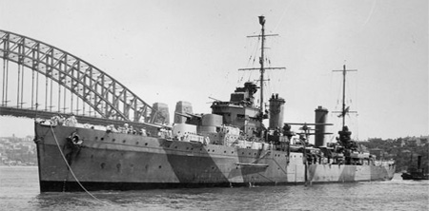
HMAS Sydney II, Sydney Harbour

Launched on the 22nd September 1934, the HMAS Sydney II was a new and valuable asset to the Royal Australian Navy, and soon became one of the most famous ships in Australian naval history. Boasting 72,000 horsepower and a length of 169m, she was a part of the Modified Leander Class of Light Cruisers and had a crew of 645. Throughout her 6 years of sea service (from when she was commissioned in 1935, to when she sank in 1941), she became a home away from home for the many men who served aboard the ship. The successor of the celebrated HMAS Sydney, a long and prosperous future seemed guaranteed, but of course, there are no promises in war.
The Sydney’s pre-WWII actions consisted largely of training and routine exercises for the newly commissioned crew. The men aboard were proud to serve on the Sydney as she was a beautifully constructed ship with a sleek design. ‘It was an exciting and proud moment for us as we watched this brand new ship – the last word in cruiser design – come gliding in, her new paintwork shining and her deck snow-white in the morning sunlight,' – Lieutenant Commander John Ross, memoir, http://www.navy.gov.au/hmas-sydney-ii-part-1.
The first to captain the Sydney was Irish-born, J.U.P FitzGerald but on the 9th October 1937, J.W.A Waller took over the role of Captain. After the declaration of war on the 3rd September 1939, a new Captain was chosen, Captain J.A Collins, who had served on Sydney for some time and had a natural ability to lead. He became the new commander of the ship on the 16th November 1939, and the Sydney and her crew ventured into the unfamiliar waters of war, under the experienced eye of Collins.
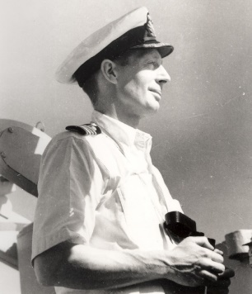
Captain J.A Collins

On the 26th May 1940, the Sydney joined the Royal Mediterranean Fleet, after finishing her duties in Fremantle. The men were aware that their actions in the Mediterranean could affect which side had control. If anything, this knowledge only pushed them further in their pursuit of success. Sydney and her crew soon became famous for defeating Italian ships including the Espero and the Bartolomeo Colleoni. After the battle with Espero, the Sydney rescued the survivors and took them on the ship as prisoners of war. The crew were apparently very friendly and hospitable and when told to go ashore to a Prisoner of War camp, many of the Espero survivors instead asked to stay aboard!
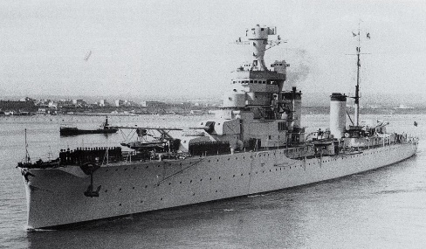
Bartolomeo Colleoni

The battle with the Italian light cruiser, Bartolomeo Colleoni (referred to as the battle of Cape Spada) remains one of the Sydney’s most celebrated victories. On the 18th July 1940, the Bartolomeo Colleoni and the light cruiser Giovanni delle Bande Nere were coming up astern of Sydney and her fleet of destroyers on patrol, ready to attack. Collins’ quick thinking and initiative resulted in the Sydney turning around and opening fire before the Italian ships could comprehend what was happening. ‘The destroyers zig-zagged eastward, dodging Italian shells as they tried to lure the enemy towards the spot where Sydney was racing at full speed… At eight twenty-eight am, Sydney opened fire at a range of some twelve miles. With superb gunfire Sydney straddled Colleoni with six in shells in her first three salvos. Later we learnt that the first fall of shells, put out every light on the Colleoni causing confusion and panic,’ – Jesse Greening, sailor aboard Sydney, extract from an autobiography, page 39, Lost – but not Forgotten. The Giovanni delle Bande Nere made a very fortunate escape, as she just managed to get away during the action with the Bartolomeo Colleoni. ‘Sydney hit the Bande Nere and there was a blinding flash – the Bande Nere had now had enough and raced for home’- Jesse Greening, sailor aboard Sydney, extract from an autobiography, page 39, Lost – but not Forgotten.

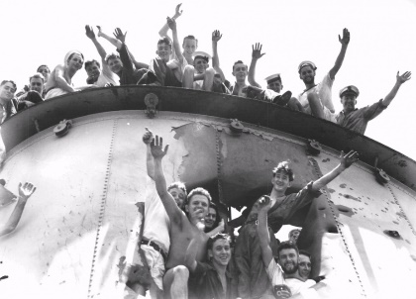
Crew of the Sydney posing through a hole in ship from Battle of Cape Spada

She became known as the ‘lucky ship’, with many near misses and close calls. ‘Here I have a fragment of a shell. Just missed me!’ – Footage of unnamed crew member of Sydney, chuckling about a near miss with a shell, The Hunt for HMAS Sydney (documentary). The crew however, may owe their luck to a very unlikely lucky charm; a tabby cat, which the crew watched for differences in behaviour. If the cat quickly ran down stairs, the men knew something was forthcoming, and the feline was always right.
Back home, the crew were rapidly gaining popularity with the public, as they heard of the spectacular successes of the Sydney. When the Sydney returned from her Mediterranean service to her namesake (9th February 1941), a huge crowd of people gave the crew a hero’s welcome. ‘The next day was the big parade throughout the city. We marched into George St, and right up to Sydney Town Hall. And there was 250,000 [people] there watching. And the kids got a holiday,’ – Jim Lavender, ex-crew member, interview, The Hunt for HMAS Sydney.
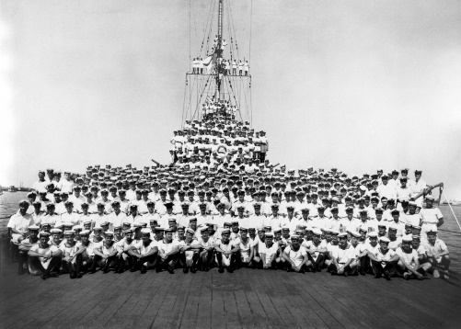
Crew of Sydney, Mediterranean

After the Mediterranean, Sydney and her men were ordered to escort troop ships to where they were stationed as the threat of an invasion of German ships was drawing nearer. Sadly, their lucky mascot cat had disappeared, leaving behind her four kittens. Some of the more superstitious men saw this as a bad omen. By now they had a new captain – Joseph Burnett, who had begun command on the ship on the 14th May- and a lot of new crew members too. On the 17th November, Sydney had just finished successfully escorting the troop ship, Zealandia, to the Sunda Straits. She was meant to reach home in 3 days. However, she never made it. The ‘lucky ship’ was gone without a trace, along with her 645 crew.

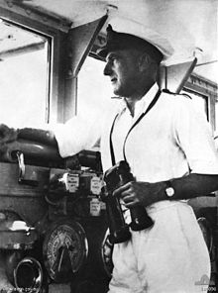
Captain Joseph Burnett

The men of the HMAS Sydney II came from all different sorts of backgrounds, from every corner of Australia. They all had different experiences aboard the Sydney as they had different duties, but the experiences they shared, demonstrated the Australian spirit – bravery in the face of danger and camaraderie. Life aboard the Sydney for some men, was spent in the anticipation of action, as their training drills did not add up to the thrill of real action. Ordinary Seaman, Victor Leslie Baker who worked in a gunnery office, tells of his experiences aboard in a letter to his brother: ‘Life has been pretty dull as usual, nothing exciting has happened... It looked as though we may have had some action, but it was only a false alarm… Our last trip with a convoy was the worst I have ever experienced, we struck the worst storm in those waters for twenty three years, you should have seen the looks on the faces of the soldiers when they landed, they looked like they had been through hell…’ - page 7, Lost but not Forgotten.
Tasks that are simple to do on land, became a whole different experience on board the Sydney. ‘I’ve just been trying to iron. I’d taken my hand off the iron for a moment and it would be swept along the table, and lob in somebody’s lap, a scream of anguish announcing its whereabouts,’- Ordinary Seaman Peter Sutherland Rudall, page 187, Lost but not Forgotten. The crew often had to adapt their lives to the ever-changing weather to try and maintain a level of comfort. Sometimes the weather permitted for the men to sleep on the deck – ‘We have had some beautiful moonlight tropical nights up here and I have been putting a blanket down and sleeping on deck,’ (Aircraftmen, 1st class Keith Homard, RAAF, letter to his parents, page 89, Lost but not Forgotten) but other times, the rough seas were an inconvenience to bear – ‘The ship shudders and creaks all the time… in fact I don’t use my hammock at sea as we are changing positions most of the night. I just roll up on the floor of the turret near the magazine or whatever it is and snore away and curse when the water comes in,’ - Ordinary Seaman Peter Sutherland Rudall, page 187, Lost but not Forgotten.
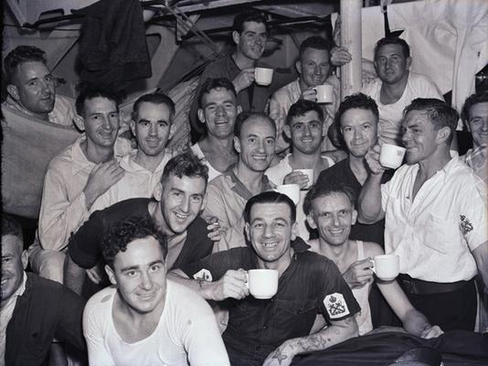
Some of the crew on Sydney
The Royal Australian Navy prohibited the consumption of alcohol – whereas the British Navy permitted it - which may have affected many of the men, as alcohol was such a huge part of the Australian culture. After the battle of Cape Spada, the Captain rewarded the crew with a gift that wasn’t exactly well received- ‘The Captain announced over the phone: In view of our victory today, all hands will be issued an extra ounce of butter. Some rude remarks went up calling him a generous so and so,’ – Tom Fisher, ex crew member, The Hunt for the HMAS Sydney. In general, many men spent their time at their posts, or else below deck or in a turret, where excitement and entertainment were rarities – ‘Time passes slowly in a turret…’ (Ordinary Seaman Peter Sutherland Rudall, page 187, Lost but not Forgotten) - though some did enjoy the time they spent on the ship, making the most of life aboard –‘…the life aboard this ship is really first class and the meals are more-or-less like a Government house touch,’ – R.B Flying Pilot Raymond Barrey, letter to his brother, http://www.navyhistory.org.au/a-letter-from-hmas-sydney/2/
Raymond Barrey

Perhaps the most challenging thing for the crew outweighed any physical tests they faced – the separation from their families and loved ones. One of the most tragic love stories of the men was that of Petty Officer Ordnance Artificer 4th class, Alan Leonard Fyffe Cunnington. In a series of loving letters to his wife, Yvonne, he expressed how sad he was that they were apart and how he longed to be with her again: ‘How I missed your lovely meals you prepared for me dearest one… I am looking forward to seeing those snaps dearest, I love to be able to have them so when I am feeling lonely I can look at you… it gives me courage. P.S I love you my dearest with all my heart and soul,’- Pages 48-50, Lost but not Forgotten. Alan applied for discharge but it was never granted. ‘My mother felt that Alan was the love of her life…. The love that she felt would never grow old, it would always be there… and no one compared [to Alan],’ -Jessie Cunnington, the daughter of Yvonne and Alan Cunnington, interview, The Hunt for HMAS Sydney. In one of her letters to Alan, Yvonne told him that she had a dream where Alan came home drunk. What she didn’t tell him, was that in the dream, he was struggling to reach her through a mist of water – a premonition of Alan’s death.
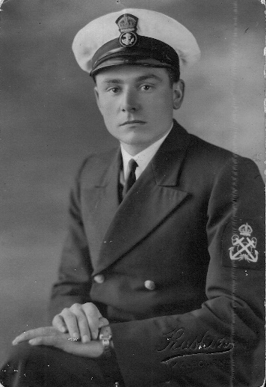
Alan Cunnington

Another story is of a love that never got the chance to bloom; newlyweds Arthur Woods and Victoria Flores were separated before they got the chance to begin their lives together. ‘We got married at 6 o’clock. It was a beautiful day…at about 2’oclock in the morning a policeman knocked on the door and he said, ‘Arthur you’ve got to report back to the ship’… I’ve never seen him again,’- Victoria Flores, interview, The Hunt for HMAS Sydney,
On the other hand, some of the men may have enjoyed being away from the responsibilities of marriage and parenting and preferred the camaraderie and companionship of navy life. In a letter to his parents, Aircraftmen 1st Class Keith Homard (who was on the Sydney along with 5 other RAAF men to man the on board Walrus Amphibian aircraft) mentions an acquaintance ‘…He looks very well which is hardly to be wondered at since he is away from that ‘beaut’ of a wife of his. He probably thinks this War will be a picnic by comparison,’ -page 90, Lost But not Forgotten.
Whilst the sound of the ‘Action Stations’ siren was a common occurrence, false alarms were more common than action. Keith Homard provides an account of this in a letter on the 7th October 1941: ‘One day last week I was on the Fo’castle having some rifle practice when “Action Stations” was sounded. In 3 minutes every man was at his post, guns loaded and ready. To our disappointment, it was one of our own [ships]… I have often wondered how I would feel if we went into action and whether I would be scared or not...’ - Page 89, Lost but not Forgotten. He goes on to say in his letter that all men dropped everything when the call to ‘Action Stations’ was sounded. “One day one of the boys was all lathered up with soap and he raced out just as he was in his birthday suit,”- Page 90, Lost but not Forgotten.
The last journey of the Sydney was only meant to be a routine escort of the ship Zealandia, something the Sydney was no stranger to. However, sharing the waters with Sydney on the North-West coast of Western Australia, was the German auxiliary cruiser, Kormoran, captained by Theodor Detmers. With many battles won under his command, he was a threat to the Australian Navy and with the largest auxiliary cruiser of the German navy on his side, Detmers was waiting for potential targets. This was not how Sydney saw Kormoran however; the German ship had disguised itself as the merchant ship, Straat Malakka. On Sydney’s approach, Kormoran fired and struck severely damaging blows on Sydney. Her early attempts to fire back missed the Kormoran and Sydney just became more crippled.
As the battle went on, Sydney managed to land some punishing hits on Kormoran, but not before she was beyond help and completely on fire. ‘The last we saw was the burning Sydney on the horizon…but we didn’t see her sinking,’ (Lt. Heinz Messerschmidt, ex Kormoran crew member, The Hunt for HMAS Sydney) and though she was gaining speed, Sydney eventually succumbed to the damage and sunk to her grave, taking all her crew with her. The Kormoran also sunk, but had 317 survivors out of its 397 crew. All the training that the Sydney’s men had done was put to waste in the real moments of crisis as there was so much confusion and uncertainty about the Kormoran’s disguise.
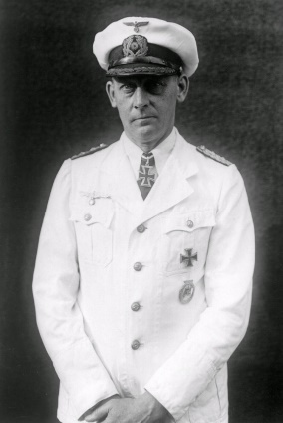
Kormoran Captain, Theodor Detmers

All accounts of the action that night (19th November, 1941) are from German survivors, including Captain Detmers. They became prisoners of war in Australia, and Detmers found an interesting way to record what unfolded that night; ‘He actually recreated the war diary of Kormoran by spelling out the account by putting small, very slight pencil marks under the letters [of a German-English dictionary] spelling out the entire account for the action with Sydney,’- David Mearns, search for Sydney director, examining the dictionary, The Hunt for HMAS Sydney. Many people refused to believe the German’s side of the story and put forward their own theories. One, was that some of the Sydney’s crew did survive the sinking, but were shot by the Germans. Another, was that a Japanese submarine was to blame for the sinking. It didn’t make sense that a crew of 645 well trained and celebrated war heroes, would just sit on a ship that they knew was sinking. A theory that is well supported by the people of the Finding Sydney Foundation, is that the men didn’t know how bad the damage was and continually made efforts to save the ship until the end, hence the Sydney gaining speed as she moved out of sight. ‘Sydney was getting away gravely damaged but intact…I don’t think they knew she was going to sink that quickly,’ - David Mearns says, as he examines evidence of the broken bowel of the wreck of Sydney, The Hunt for HMAS Sydney.
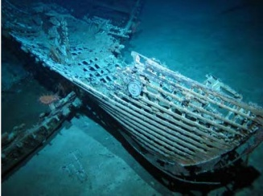
Part of the wreck of Sydney

The Finding Sydney Foundation was dedicated to finding the Sydney’s final resting place, and in late 2007, finally received the funding they needed to start searching. On the 12th March 2008, the Kormoran was located and only 4 days after, Sydney was found. Finally, 67 years later, there was some consolation for the remaining relatives of the Sydney’s men as their resting place was found. At the time of the sinking, the Australian Government treated the manner with much secrecy as there were many unknowns in the equation of the disappearance of Sydney – ‘There could have been other German raiders at large in the Indian Ocean…[the fact that] one of our cruisers was no longer there to counter that threat could’ve encouraged further raider activity,’- Lt. John Perryman RANR, The Hunt for HMAS Sydney.
The families of the men were subjected to tremendous amounts of anxiety and false hope as the only information they had been given was that their family member was ‘missing at sea.’ ‘Our loss was unbelievable. My Mother immediately tried to protect us from the immense grief she felt…If father was ‘lost at sea’ then maybe he would turn up somewhere on an island…or even be a prisoner of the Japanese… It could’ve been a terrible mistake and would all come right in the end,’ – Barbra Craill, daughter of Able Seaman Walter Freer, page 66, HMAS Sydney (II).

Confirmation of the men’s death was not given until years later. However, nothing could make up for the loss of their brave loved ones, in a tragedy that the entire nation grieved for. ‘I said to him once, “You might get killed.” His answer was you have to die sometime so it might as well be for your King and Country,’- Rhonda Wakefield, sister to Able Seaman David Andrew Gwynne, page 82, Lost but not Forgotten. Pat Burnett, the son of Captain Joseph Burnett, read what his father wrote to him in one of his last letters: ‘Don’t forget what I said, when at home, about thinking things and problems out for yourselves. Good luck old chap, make lots of runs and keep the bat oiled. Keep fit, much love and hugs, from dad,’- The Hunt for HMAS Sydney.
Stoker Jack Crowle, wrote this letter to his mother, in case something ever happened to him during service: To mum, Although I know it will be a blow to you, I don’t want you to grieve, as I have finished my time on earth and have gone to a better place. You will disappoint me greatly if you do not carry on. My death would not mean that your struggles and sacrifices have been in vain, it just means that your sacrifice was as great as mine. However great this sacrifice is, remember I lived and died an Australian and I don’t think there is any greater honour. I am not afraid of death, and would prefer to die in no other way than in doing my duty,’- page 46, HMAS Sydey (II).
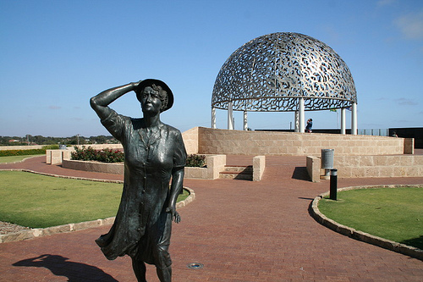
Memorial for Sydney and Waiting Woman Sculpture, who is said to be waiting for her loved one to return.

The HMAS Sydney II was the pride of the Australian Navy, a fine ship that was a great service to its country. In the words of Captain J.A Collins, ‘…There has never been before nor will there ever be again, a ship quite to compare with the cruiser Sydney of World War II,’-http://www.navy.gov.au/hmas-sydney-ii-part-2. The sinking of the Sydney remains the single worst loss of life in the history of the Australian Navy. It rests with its 645 crew, who were dedicated and courageous men. Their actions in the Mediterranean were cause for celebration in Australia, and their ‘bitter sweet victory’ (Lost But not Forgotten, full title Lost but not Forgotten – A bitter Sweet Victory) against Kormoran, may have prevented the loss of many other Australian ships.
Let us salute the HMAS Sydney II and her men for their selfless gallantry and loyalty to their country. May they rest in peace.
Lest we forget
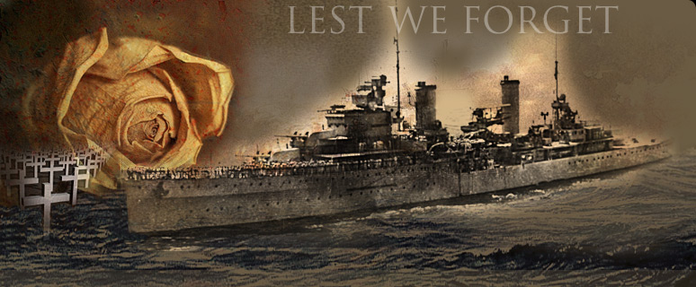

By Tahlia Grammatopoulos

Bibliography:
Websites -
http://trove.nla.gov.au/newspaper/article/11008293
http://www.sydneymemorial.com/history.htm
http://museum.wa.gov.au/explore/sydney/history-hmas-sydney-ii
https://www.awm.gov.au/encyclopedia/hmas_sydney/detmers/
https://www.navyhistory.org.au/a-letter-from-hmas-sydney/
Books -
Lost – But Not Forgotten, A Bitter Sweet Victory, HMAS Sydney II, In Memory of the 645. Author – Keith Shegog. Published in 2002.
HMAS Sydney (II). Author – M. Mcarthy. Published in 2010
The Search for HMAS Sydney, an Australian Story. Authors/Contrinutors – Ted Graham, Bob King, Bob Trotter, Kim Kirsner. Published in 2014
Documentary -
The Hunt for HMAS Sydney, Solving Australia’s Most Enduring Maritime Mystery. Directed by Matthew Kelly. Producers - Andrew Ogilvie, Andrea Quesnelle. Released in 2008
Pictures
http://www.navy.gov.au/hmas-sydney-ii-part-1
http://www.navy.gov.au/hmas-sydney-ii-part-2
Google images:
https://www.google.com/search?site=&tbm=isch&source=hp&biw=2163&bih=1311&q=hmas+sydney+II+&oq=hmas+sydney+II+&gs_l=img.3..0j0i30k1l3j0i24k1l5.6252.8116.0.8296.15.8.0.1.1.0.511.1231.2-1j0j1j1.3.0....0...1ac.1.64.img..12.3.823.7Hixr6w_n3Y#imgrc=0Txau1F0l-VMFM%3A
https://www.google.com/search?site=&tbm=isch&source=hp&biw=2163&bih=1311&q=hmas+sydney+II+&oq=hmas+sydney+II+&gs_l=img.3..0j0i30k1l3j0i24k1l5.6252.8116.0.8296.15.8.0.1.1.0.511.1231.2-1j0j1j1.3.0....0...1ac.1.64.img..12.3.823.7Hixr6w_n3Y#tbm=isch&q=hmas+sydney+crew&imgrc=PR3Lkgqjy9s29M%3A
https://www.google.com/search?site=&tbm=isch&source=hp&biw=2163&bih=1311&q=hmas+sydney+II+&oq=hmas+sydney+II+&gs_l=img.3..0j0i30k1l3j0i24k1l5.6252.8116.0.8296.15.8.0.1.1.0.511.1231.2-1j0j1j1.3.0....0...1ac.1.64.img..12.3.823.7Hixr6w_n3Y#tbm=isch&q=captain+joesph+burnett&imgrc=Jxshb-nzRD6quM%3A
https://www.google.com/search?site=&tbm=isch&source=hp&biw=2163&bih=1311&q=hmas+sydney+II+&oq=hmas+sydney+II+&gs_l=img.3..0j0i30k1l3j0i24k1l5.6252.8116.0.8296.15.8.0.1.1.0.511.1231.2-1j0j1j1.3.0....0...1ac.1.64.img..12.3.823.7Hixr6w_n3Y#imgrc=1k2cioCejAtHUM%3A

