Winners of the WW2 History Competition, 2016

The Baxter & Grimshaw Trust, in association with the History Teachers’ Association South Australia, had great pleasure in announcing joint winners of the 2016 WW2 History Competition.
Tahlia Grammatopoulos, Salisbury East High School, with her essay tracing the history of HMAS Sydney II. Tahlia gave an excellent presentation of her essay at a Seven Seas Club dinner.
Class 10A, Mark Oliphant College, Munno Para, supported by Teacher, Elspeth Grant, with their multi-media, pop-up museum video titled,”1942— Our War in the Pacific”.
The two winning entries can be viewed below.
The prizes were presented to the recipients by Peter Allen AM, Chair, Baxter & Grimshaw Trust, at the HTASA State Conference on 26th August, 2016, in Adelaide. A further presentation was made by Peter Allen to Class 10A participants at a senior assembly at Mark Oliphant College.

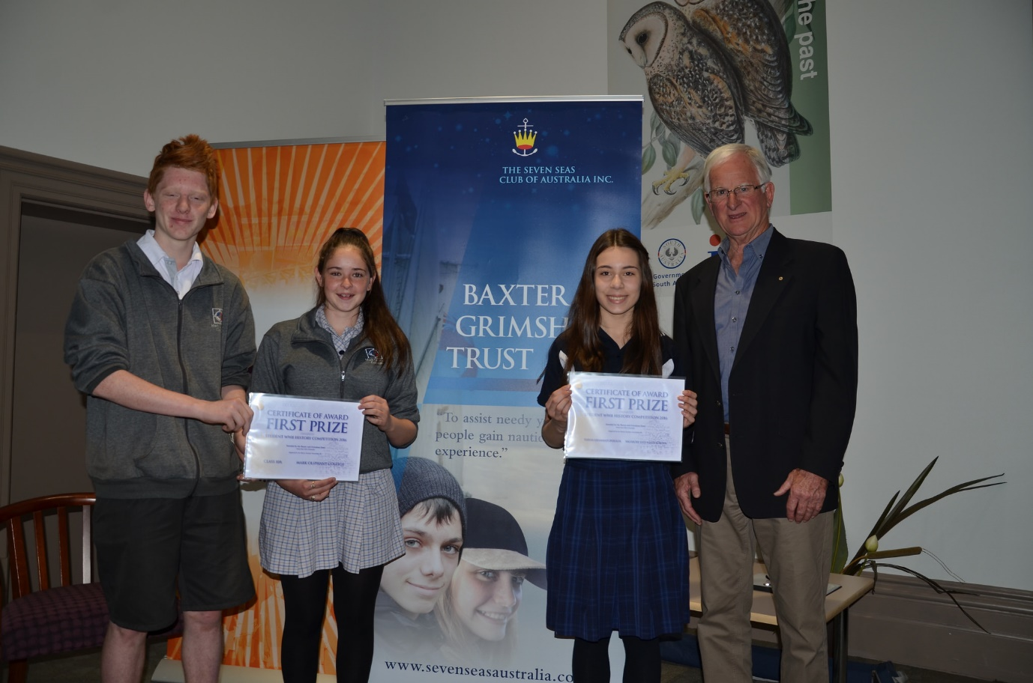

Joint winners of the 2016 History Competition following the presentation at the History Teachers’ Association South Australia’s State Conference.
From LHS: Kobe Boyd and Emily Holland, representing Class 10A, Mark Oliphant College, Tahlia Grammatopoulos, Salisbury East HS, Peter Allen, Chair, Baxter & Grimshaw Trust.

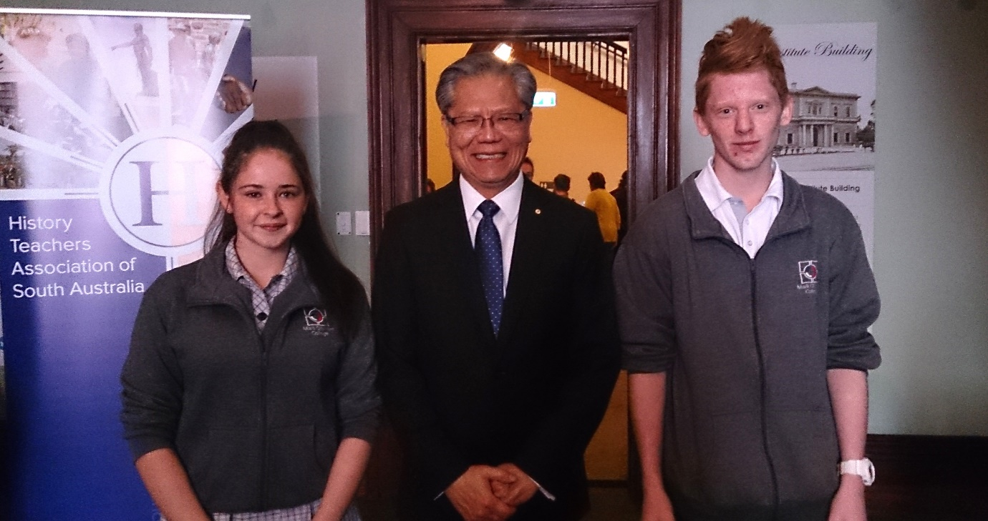

His Excellency the Honourable Hieu Van Le AC, Governor of South Australia, with Emily Holland and Kobe Boyd, Mark Oliphant College, following the presentations to the winners of the WW2 History Competition at the History Teachers’ Association SA Annual Conference, 2016.

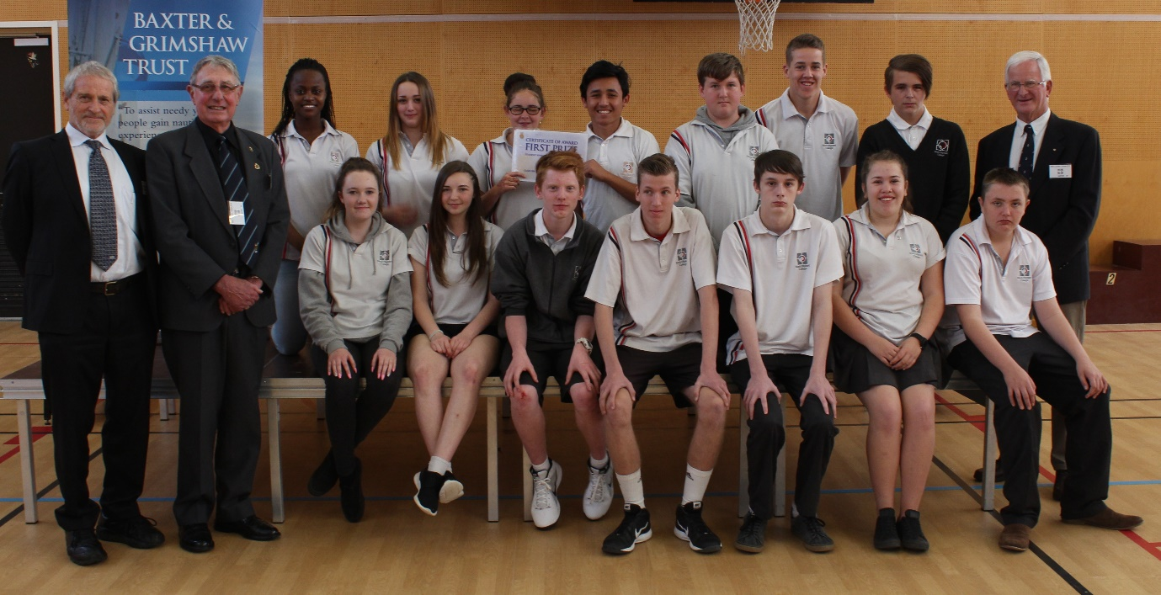

Class 10A, Mark Oliphant College, participants in the winning video following the presentation at the College’s senior assembly.
From LHS: Back row - Gloria, Jade, Emily, Mehdi, Jonathon, Rhys, Bradly, Peter Allen, Chair, Baxter & Grimshaw Trust.
Front row - David Tucker and Geoff Turner, Gawler National Trust, Rhianna, Aisha, Kobe, Kyle, Matt Bianca, Jackson.

